INTRODUCTION TO PROMISES

It is basically promise of executing a code //tailor wali example

3 stages of promises

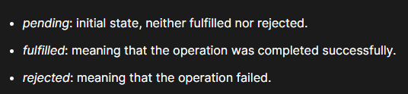

# 

Use capital P for initializing promise

Promise has two properties 1:state and 2: result

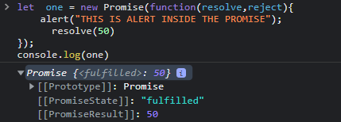

Promise is basically used for parallel execution//kyuke neechaay first 3 statements ko one by one krnay ka koi point nahi hai yeh ek sath execute honi chaheye

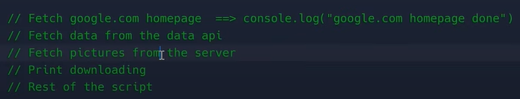

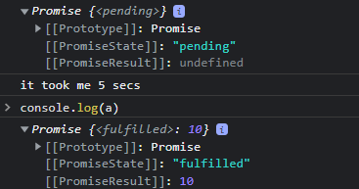

<https://youtu.be/Dadlf6YsTHA>

<https://replit.com/@Hasnain150/introToPromises-20#index.js>